Janus Log

Janus log session grouping

Task: Group interleaved Janus WebRTC server log lines by session, in chronological order, without altering any original log content.

Janus is a WebRTC media server. Its log file records events from many concurrent sessions (phone calls / video calls) all interleaved together in the order they happened in real time, not grouped by which call they belong to.

A single log file used for this task contained 171,279 lines spanning roughly one month of activity and 12,270 distinct sessions, which includes 12,252 normal sessions and the rest being either orphan sessions, truncated by restart, or which are still open at EOF (End of file).
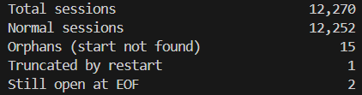

Goal: produce a new log file containing every original line, reproduced exactly as-is, but reorganized so that all lines belonging to one session are grouped together and appear in chronological order, instead of interleaved with unrelated sessions the way the source file is.

The large majority of log lines do not contain a session ID directly. Most lines reference either a handle ID (an internal ID tied to one leg of a call) or a raw memory pointer (a hex address like 0x7f4fdc002fd0), and these have to be traced back to a session through other lines. Memory addresses are reused once Janus frees an object, which makes naive pointer-based lookup unsafe if not handled carefully.

2026-08-21T00:01:58.806083+0600 janus-test sudo[3273]: Creating new session: 4653754810525284; 0x7f4fdc002fd0
2026-08-21T00:01:58.865002+0600 janus-test sudo[3273]: Creating new handle in session 4653754810525284: 193865524489355; 0x7f4fdc002fd0 0x7f4fdc00af70
2026-08-21T00:01:58.895100+0600 janus-test sudo[3273]: sres: /etc/resolv.conf: unknown option
2026-08-21T00:01:59.243685+0600 janus-test sudo[3273]: [193865524489355] Creating ICE agent (ICE Lite mode, controlled)
2026-08-21T00:02:04.476630+0600 janus-test sudo[3273]: [193865524489355] The DTLS handshake has been completed
2026-08-21T00:02:04.476630+0600 janus-test sudo[3273]: [janus.plugin.sip-0x7f4f8c01ac80] WebRTC media is now available
2026-08-21T00:02:06.088405+0600 janus-test sudo[3273]: [WARN] [SIP-09638009771] Got a 'Connection refused' on the audio RTCP socket, closing it
2026-08-21T00:04:09.237666+0600 janus-test sudo[3273]: [janus.plugin.sip-0x7f4f8c00d1f0] No WebRTC media anymore
2026-08-21T00:04:09.246227+0600 janus-test sudo[3273]: [1005146296845126] WebRTC resources freed; 0x7f4fdc009410 0x7f4fdc007420
2026-08-21T00:04:09.290603+0600 janus-test sudo[3273]: [ERR] [plugins/janus_sip.c:janus_sip_handler:4675] Wrong state (not established/inviting/progress? status=idle)
2026-08-21T00:04:09.352176+0600 janus-test sudo[3273]: Detaching handle from JANUS SIP plugin; 0x7f4fdc009410 0x7f4f8c00d1f0 0x7f4fdc009410 0x7f4fdc00ba30
2026-08-21T00:04:09.412947+0600 janus-test sudo[3273]: Destroying session 7280510213952357; 0x7f4fdc007420
2026-08-21T00:04:09.517782+0600 janus-test sudo[3273]: [WSS-0x7f4f8c021090] Destroying WebSocket client
2026-08-21T00:04:10.247324+0600 janus-test sudo[3273]: [1005146296845126] Handle and related resources freed; 0x7f4fdc009410 0x7f4fdc007420
2026-08-21T00:06:04.340363+0600 janus-test sudo[3273]: Creating new session: 7869608923105757; 0x7f4f8c01b690
2026-08-21T00:06:04.371980+0600 janus-test sudo[3273]: Creating new handle in session 7869608923105757: 3066738104914293; 0x7f4f8c01b690 0x7f4fdc011eb0
2026-08-21T00:06:04.403795+0600 janus-test sudo[3273]: sres: /etc/resolv.conf: unknown option

Preparation: Before diving into any sort of code or logic, it was first needed to determine what unique kind of line formats actually exists in the log file, so that the regular expressions can later be created with respect to those. Secondly, the identification of lines which carry enough information to resolve handles or sessions without guessing was necessary. This is why a small script (find_unique_line_patterns.py) was used to solve this cheaply. It normalizes every hex value and long numeric ID in each line into placeholders (<HEX>, <BIGNUM>) before comparing lines, so that lines which are functionally identical except for their specific IDs, for example, every one of the thousands of “Creating new sessions: …” lines collapse into a single representative example.

Running this against the full 171,279-line file reduced it to 186 unique structural patterns, small enough to read through by hand and categorize.
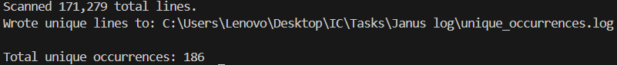

4 distinct findings were discovered via running this file:

- Multiple distinct identifier types in play: session IDs, handle IDs, and several different families of memory pointers (core session/handle pointers, plugin-session pointers, WebSocket pointers).
- A process restart occurs once, partway through the file, visible through a block of systemd/service lifecycle lines and a change in process ID.
- Orphaned sessions and handles, IDs that appear via a "destroy" or "freed" line with no corresponding "create" line anywhere earlier in the file, implying the session began before the file's visible window started.
- A mix of self-resolving error lines (which name a session or handle ID directly in their text) and context-only lines (which carry no ID or pointer of any kind, e.g. sres: /etc/resolv.conf: unknown option).

The approach: Two types of different approaches were tried in order to group the session related information in chronological order as best as possible. Both of them share the overall two-pass method. The simplified view is given below:

main()
├── Pass 1 (read every line once)
│ → builds lookup tables: which handle belongs to which session,
│ and the history of which handle(s) have used each memory address
├── Preparation step
│ → accounts for handles that were clearly alive before the file began
├── Pass 2 (read every line again)
│ → uses the Pass 1 tables to resolve and assign every line to a session
├── Finalize
│ → labels any session still "open" at end-of-file
└── Write output
→ one block per session, sorted by when it first appeared, each
containing its lines in original chronological order

A single forward-only pass cannot always know, at the moment it reads an ambiguous line (one identified only by a memory pointer, not a direct ID), which handle currently owns that pointer, because the proof of ownership might only appear in a later line. Reading the entire file once first (Pass 1) guarantees Pass 2 always has the complete picture before it commits to any decision, regardless of which order the relevant lines happen to appear in.

Both versions try the following checks, in this order, for every line, and use the first one that matches:

- Boot marker / server-restart lines → routed to a separate "global" section, never guessed into a session.
- Other non-session diagnostic lines (e.g. [rtp-sample]) → also global.
- Self-resolving error lines that name a session/handle ID directly in their own text.
- Direct structural lines: Creating new session, Creating new handle, Destroying session, Handle ... freed, or any line starting with a bracketed numeric handle ID.
- Pointer-only lines (Detaching handle from JANUS ... plugin, [janus.plugin.NAME-hex] ...), resolved by looking up which handle currently owns that memory address.
- Fallback: attribute the line to whichever session was most recently and successfully resolved. This is a best-effort guess used only when a line carries no ID or pointer of its own.

Version 1 (group_janus_sessions.py) tracked whether a handle was currently "alive" using a single boolean set:

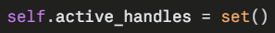

A handle's ID was added to this set when created, and removed when freed. To resolve which handle a reused memory address belonged to, the script walked that address's recorded history of past handles (most recent first) and returned the first one currently sitting in the set, a single global on/off flag, with no timestamp involved in the check at all.

The plugin memory address 0x7f4f8c01ac80 was used by session 4653754810525284's handle early in its lifetime. Once that handle was freed, nothing about the flag-based check prevented a different, unrelated session, created 21 hours later, from reusing that exact same address and being matched to the old session, because "is this handle flagged active" carries no sense of when that flag was last true relative to the line being resolved.
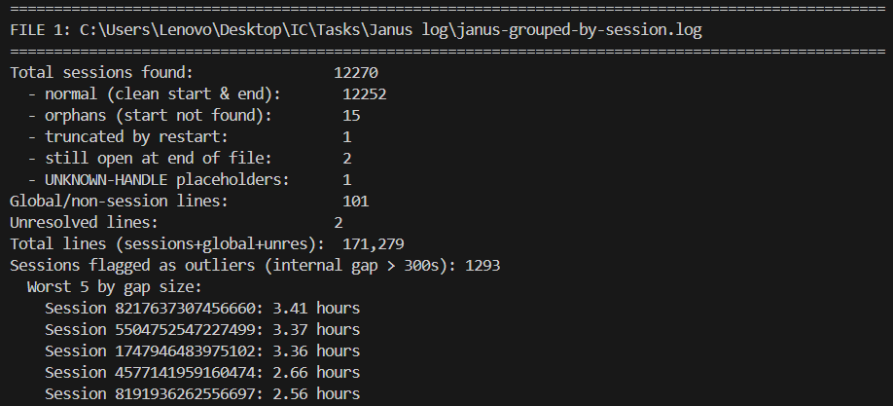

Version 2 (group-janus-sessions-timestampled.py) replaced the single boolean flag with a genuine time interval per handle:

The fundamental question of the logic is changed with a simple tweak. Instead of "is this handle flagged alive right now, in some global sense," it asks: "was this handle specifically alive at the exact timestamp of the line I'm resolving?"

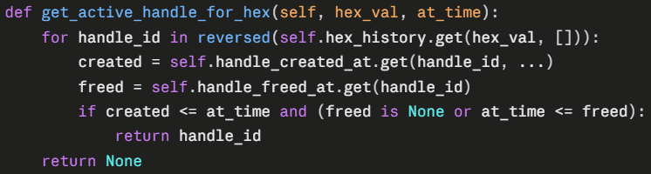

With this change, for example, the 21:03 lines fall outside the first handle's window (which ends at 00:09:46), so they correctly fail to match it and instead resolve to whichever handle actually owned that address at 21:03. Every handle's ownership window is now unambiguous by construction, for any address, at any point in the file, regardless of the order in which the revealing lines happen to appear. Version 2 also tracks, per session, the largest gap between two consecutive attributed lines, and annotates the session's header automatically if that gap exceeds a configurable threshold (5 minutes by default, but can be configured as needed):

=== Session 4653754810525284 (first seen 2026-08-21T00:01:58.806083+0600) [WARNING: internal gap of 7m40s - verify manually] ===

Implementing this check makes the detection for outliers much easier and also more logical.

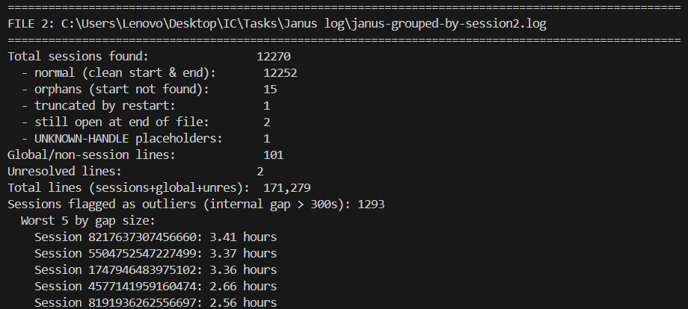

Restart handling: Both versions detect the one process restart present in the file (via a systemd log line announcing the service restarted) and treat it as a hard reset point. Version 1 simply clears its active_handles set. Version 2 instead force-closes the interval of every handle still open at that moment, setting its freed_at to the restart's own timestamp, ensuring no handle's ownership window can ever wrongly extend across a process restart, even though the new process may reuse the same memory addresses.

Comparison of both versions of the .py scripts

A dedicated script, compare_grouped_outputs.py, was built to compare the two versions' output on the real, full-sized 171,279-line file. It performs a side-by-side count comparison (total sessions, sessions by status, placeholder sessions, global/diagnostic line count, unresolved line count, total line count as a data-loss sanity check), and an automatic count of sessions flagged for a large internal time gap.

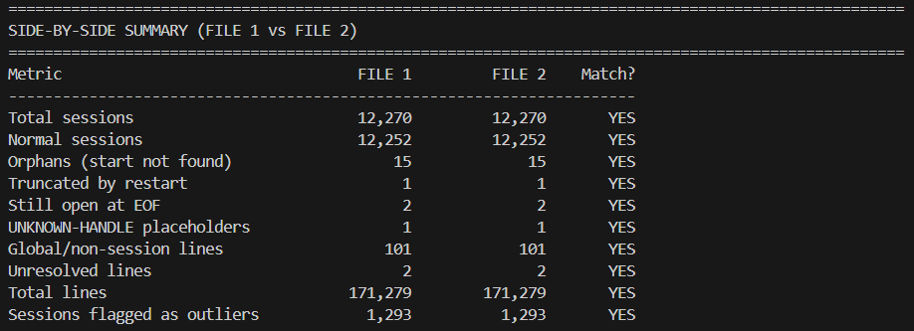

Result: Even though both versions produced the exact same metrics as per the comparison table given above, version 2 remains to be the more structurally correct implementation of the task, since it takes into account the life cycle of a session by monitoring the timestamps closely while grouping the events of one session all together.

Making the csv: The newly created log files are now used as inputs, and the output is a csv file where each row corresponds to one Janus session. This stage extracts and represents the following information in the csv file:

- Extracts identifying fields per session (session ID, handle ID, SIP identifier, call type).
- Computes timing and count fields (start, end, duration, event, warning and error counts, first/last error time).
- Detects lifecycle milestones (ICE, DTLS, WebRTC media up/down, destroy).
- Classifies each call as Complete if the webrtc_up is assigned to “TRUE”, otherwise Incomplete.
- Preserves every raw log line per session so any row can be audited.

Classifying the call types: call_type records which Janus plugin handled the session. It is not a protocol classification.
Every session in this log is a WebRTC session on the browser side, because Janus is a WebRTC server. The SIP plugin acts as a bridge: the browser speaks WebRTC to Janus, and Janus translates to SIP toward an external endpoint such as a PBX or trunk provider. The VideoCall plugin keeps the whole call inside Janus, WebRTC end to end, with no SIP involved. UNKNOWN means no plugin line appeared in the session. This typically indicates a session that failed or was cut off before reaching a plugin.

Lifecycle milestones: 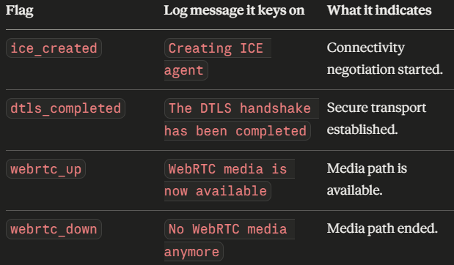

Final csv output:
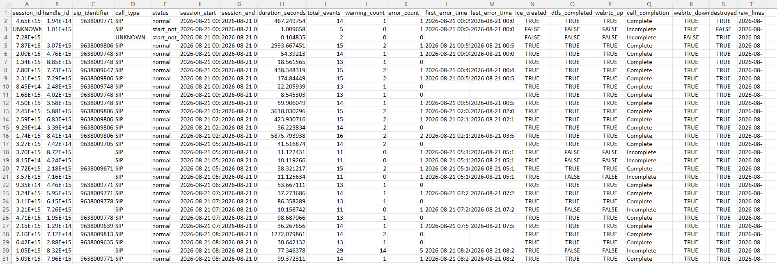

Ubuntu and FreeSwitch setup

FreeSWITCH SIP Server Setup on Ubuntu (Dual Boot)

Ubuntu Installation

Version installed

Ubuntu was installed in dual boot alongside Windows 11 on the same laptop's NVMe SSD, with /home placed on a separate HDD.

Distributor ID: Ubuntu
Description: Ubuntu 24.04.5 LTS
Release: 24.04
Codename: noble

Linux Lenovo 7.0.0-34-generic #34~24.04.1-Ubuntu SMP PREEMPT_DYNAMIC Fri Sep 4 15:38:29 UTC 2 x86_64 x86_64 x86_64 GNU/Linux

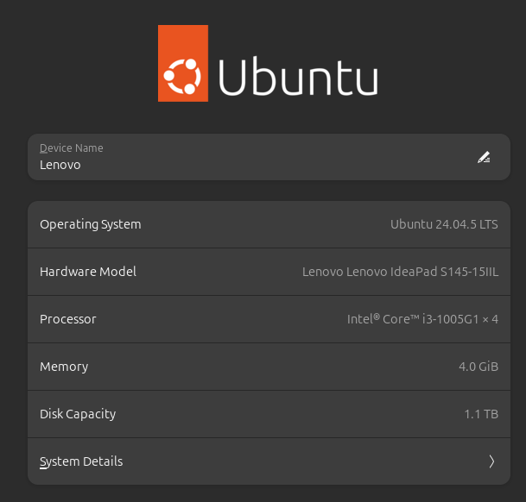

Post-install terminal setup
1. After first boot into Ubuntu, the system was updated and basic tools were installed:
sudo apt update && sudo apt upgrade -y
2. Additional drivers were checked and installed via:
Settings > Software & Updates > Additional Drivers, or via terminal:
sudo ubuntu-drivers autoinstall
3. Clock sync issue between Windows and Ubuntu was fixed with:
timedatectl set-local-rtc 1 --adjust-system-clock

FreeSWITCH Installation (From Source)
FreeSWITCH's official pre-built binary packages now require a SignalWire Personal Access Token and, as of installation time, did not have confirmed support for Ubuntu 24.04 (noble). The source build method was chosen instead, which requires no token and is documented for Ubuntu 22.04/24.04.
FreeSWITCH version built: v1.10.12

Prerequisites
- Ubuntu 24.04 LTS installed and updated
- At least 5 GB free space on the root partition
- Charger connected (long-running compile)
- Port 5060 confirmed free using the command
sudo ss -lunp | grep 5060

Step-by-step installation commands
Step 1 — Open root shell and set build variables
sudo -i
mkdir -p /home/nazmul/fsbuild
FS_VERSION=v1.10.12
BUILD_DIR=/home/nazmul/fsbuild
PREFIX=/usr/local/freeswitch
JOBS=2

Note: JOBS=2 was used instead of nproc (all cores) to avoid exhausting the laptop's 4GB RAM during compilation.
Step 2 — Install build dependencies
export DEBIAN_FRONTEND=noninteractive
apt-get update
apt-get install -y --no-install-recommends \
git build-essential cmake automake autoconf libtool libtool-bin pkg-config \
ca-certificates wget unzip uuid-dev \
libssl-dev zlib1g-dev libdb-dev libsqlite3-dev libcurl4-openssl-dev \
libpcre3-dev libspeex-dev libspeexdsp-dev libldns-dev libedit-dev \
libtiff-dev libjpeg-dev libopus-dev libsndfile1-dev libavformat-dev \
libswscale-dev libswresample-dev libpq-dev liblua5.2-dev \
yasm nasm
Step 3 — Build libks
cd "$BUILD_DIR"
git clone https://github.com/signalwire/libks.git || true
cd libks
git pull --ff-only
cmake . -DCMAKE_INSTALL_PREFIX=/usr
make -j"$JOBS"
make install
Step 4 — Build sofia-sip (SIP stack)
cd "$BUILD_DIR"
git clone https://github.com/freeswitch/sofia-sip.git || true
cd sofia-sip
git pull --ff-only
./bootstrap.sh
./configure --prefix=/usr
make -j"$JOBS"
make install

Step 5 — Build spandsp (pinned to a compatible commit)
cd "$BUILD_DIR"
git clone https://github.com/freeswitch/spandsp.git || true
cd spandsp
git fetch --all --tags
git checkout d9681c3747ff4f56b1876557b9f6d894b7e6c18d~1
./bootstrap.sh
./configure --prefix=/usr
make -j"$JOBS"
make install
ldconfig
Step 6 — Clone FreeSWITCH and disable mod_signalwire
mod_signalwire requires a proprietary library only available from SignalWire's token-gated repo, and was excluded since a token-free source build was chosen.
cd "$BUILD_DIR"
git clone https://github.com/signalwire/freeswitch.git || true
cd freeswitch
git fetch --tags
git checkout "$FS_VERSION"
./bootstrap.sh -j
sed -i 's|^applications/mod_signalwire|#applications/mod_signalwire|' modules.conf
Step 7 — Configure, compile, and install
./configure --prefix="$PREFIX" \
--enable-core-pgsql-support \
--disable-dependency-tracking
make -j"$JOBS"
make install
Issue encountered: The build failed on mod_av due to incompatibility between FreeSWITCH 1.10.12's code and Ubuntu 24.04's newer FFmpeg/libav headers (priv_data_size removed, ticks_per_frame deprecated, treated as a hard error). mod_av handles video file format support and was not required for SIP voice calling, so it was disabled:
sed -i 's|^applications/mod_av|#applications/mod_av|' modules.conf
make -j"$JOBS"
make install

Step 8 — Install default sample configuration
Note: make install alone does not install the config files. This step is required separately.
make samples
This installed the configuration to: /usr/local/freeswitch/etc/freeswitch/
Step 9 — Install default sounds and music-on-hold
make cd-sounds-install cd-moh-install
ldconfig
Step 10 — Create a dedicated system user
id -u freeswitch >/dev/null 2>&1 || useradd --system --home "$PREFIX" --shell /sbin/nologin freeswitch
chown -R freeswitch:freeswitch "$PREFIX"
Step 11 — Create the systemd service
cat >/etc/systemd/system/freeswitch.service <<EOF
[Unit]
Description=FreeSWITCH Telephony Platform
After=network-online.target
Wants=network-online.target
[Service]
Type=forking
User=freeswitch
Group=freeswitch
LimitCORE=infinity
LimitNOFILE=100000
LimitNPROC=60000
LimitSTACK=250000
LimitRTPRIO=infinity
LimitRTTIME=7000000
ExecStart=${PREFIX}/bin/freeswitch -ncwait -nonat
ExecReload=${PREFIX}/bin/fs_cli -x reloadxml
Restart=on-failure
RestartSec=5
[Install]
WantedBy=multi-user.target
EOF
systemctl daemon-reload
Step 12 — Add convenience symlinks
ln -sf "$PREFIX/bin/freeswitch" /usr/local/bin/freeswitch
ln -sf "$PREFIX/bin/fs_cli" /usr/local/bin/fs_cli
Step 13 — Fix ownership after config install
chown -R freeswitch:freeswitch /usr/local/freeswitch
Step 14 — Start and verify
systemctl start freeswitch
systemctl status freeswitch --no-pager
Recording the installed version: nazmul@Lenovo:~$ /usr/local/freeswitch/bin/freeswitch -version
FreeSWITCH version: 1.10.12-release+git~20240802T210227Z~a88d069d6f~64bit (git a88d069 2024-08-02 21:02:27Z 64bit)

Security hardening applied
Default credentials were changed before any external use:
1. Default extension password — edited in:
/usr/local/freeswitch/etc/freeswitch/vars.xml
Changed the default_password value from the default to a custom password.
2. Event socket password — edited in:
/usr/local/freeswitch/etc/freeswitch/autoload_configs/event_socket.conf.xml
Changed from the default ClueCon to a custom password. Changes applied with:
chown -R freeswitch:freeswitch /usr/local/freeswitch
systemctl restart freeswitch

SIP Extension & Call Setup (MizuDroid, Two Android Phones)
Network prerequisite
Both Android phones and the Ubuntu PC must be on the same local Wi-Fi network.
PC's local IP address, obtained via:
ip a
Output:
1: lo: <LOOPBACK,UP,LOWER_UP> mtu 65536 qdisc noqueue state UNKNOWN group
default qlen 1000
link/loopback 00:00:00:00:00:00 brd 00:00:00:00:00:00
inet 127.0.0.1/8 scope host lo
valid_lft forever preferred_lft forever
inet6 ::1/128 scope host noprefixroute
valid_lft forever preferred_lft forever
2: wlp1s0: <BROADCAST,MULTICAST,UP,LOWER_UP> mtu 1500 qdisc noqueue state UP group default qlen 1000
link/ether 28:39:26:e5:33:db brd ff:ff:ff:ff:ff:ff
inet 192.168.97.48/21 brd 192.168.103.255 scope global dynamic noprefixroute wlp1s0
valid_lft 3138sec preferred_lft 3138sec
inet6 fe80::a025:d12e:c2ff:416b/64 scope link noprefixroute
valid_lft forever preferred_lft forever
If UFW is active, the following ports must be allowed: 5060/udp for SIP signaling, 16384:32768/udp for RTP media.)
SIP profile verification
Confirm the internal SIP profile is running:
fs_cli -p <event_socket_password>
sofia status

Extension credentials used
The default sample configuration ships with pre-configured extensions 1000–1019, sharing the default_password variable set in vars.xml.
Extension configuration files are located at:
/usr/local/freeswitch/etc/freeswitch/directory/default/<extension>.xml
Two extensions were used for this test:

Extension | Purpose | Password
1000 | Phone A | 1234
1001 | Phone B | 1234

MizuDroid configuration — Phone A (Extension 1000)
App: MizuDroid, installed on Android Phone A.
New SIP account created with:
- SIP Server / Domain: 192.168.97.48
- Username: 1000
- Auth Username: 1000
- Password: 1234
- Transport: UDP
- Port: default (5060 — not manually entered, app defaults to standard SIP port)

MizuDroid configuration — Phone B (Extension 1001)
Identical setup on Android Phone B, using extension 1001 instead of 1000.
- SIP Server / Domain: 192.168.97.48
- Username: 1001
- Auth Username: 1001
- Password: 1234
- Transport: UDP

Registration verification
From the FreeSWITCH console, both extensions were confirmed as registered:
sofia status profile internal reg

Making a test call
From Phone A (extension 1000), the extension 1001 was dialed directly from the MizuDroid keypad.
Result: Phone B received an incoming call, was answered, and two-way audio was confirmed working in both directions.

Manipulate a voicemail

Setting up a voicemail instead of regular call and auto hang-up

Step 1: Prepare custom voicemail audio file

espeak has been used to create a custom voicemail line for testing purposes.

sudo apt install espeak -y
espeak "This is a test voicemail message. Goodbye." -w /home/nazmul/custom_message.wav

Step 2: Move it into FreeSWITCH's sounds directory

sudo mkdir -p /usr/local/freeswitch/sounds/custom
sudo cp /home/nazmul/custom_message.wav /usr/local/freeswitch/sounds/custom/
sudo chown -R freeswitch:freeswitch /usr/local/freeswitch/sounds/custom

Step 3: Edit the dialplan

Open the default dialplan:

sudo nano /usr/local/freeswitch/etc/freeswitch/dialplan/default.xml

Add a new extension code block just before the Local_Extension block in the .xml file.

<extension name="voicemail_intercept_1001">
<condition field="destination_number" expression="^1001$">
<action application="answer"/>
<action application="playback" data="/usr/local/freeswitch/sounds/custom/custom_message.wav"/>
<action application="hangup"/>
</condition>
</extension>

This new block must appear before the existing extension that normally routes calls to registered users, since FreeSWITCH dialplan matching stops at the first matching condition per extension tag, and extensions are evaluated top to bottom. If it's placed after the existing catch-all user-routing extension, that one will match first and 1001 will ring normally instead.

Save (Ctrl+O, Enter) and exit (Ctrl+X).

Step 4: Reload the dialplan without restarting the whole service

fs_cli -p <your_event_socket_password> -x "reloadxml"

Step 5: Test it
From Phone A (extension 1000), dial 1001.
Expected result: Phone B should not ring at all. Phone A should hear the custom message play, then the call should disconnect automatically.

